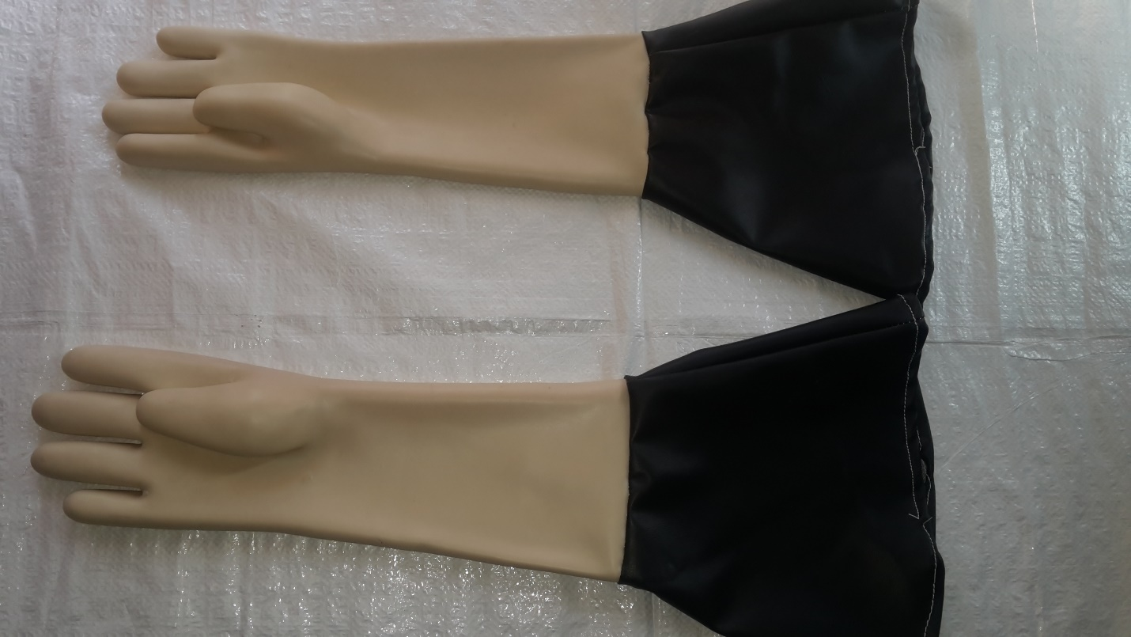

FULL RUBBER WITH REXINE GAUNTLET.LENGTH TOTAL 25” (750MM)WITH 8” (200MM) DIA GAUNTLET OPENING.

CAN SUPPLY WITHOUT GAUNTLET OR GAUNTLET OF REQUIRED SIZES.

APPLICATION:

SANDBLASTING CABINET

IDEAL FOR WORKING IN GLASSBEADS/WIRESHOTS ETC.WITHSTANDS AIR PRESSURE INSIDE THE CABINET.

MADE OF THICK RUBBER.